Patient Participation Enhanced Service 2014/15 Annex D: Standard Reporting Template
London Region South London Area Team
Complete and return to: nhscb.lon-sth-pcc@nhs.net by no later than 31st March 2015
Practice Name: Welling Medical Practice
Practice Code: G83025
Signed on behalf of the Practice:  Signed on behalf of the PPG: | 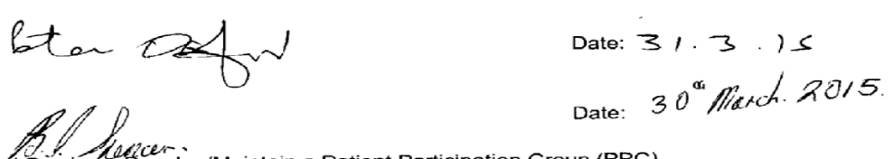

- Prerequisite of Enhanced Service – Develop/Maintain a Patient Participation Group (PPG)
Does the Practice have a PPG? Yes

Methods of Engagement with the PPG: Face to Face, Email, Other (please specify) Face to face and email

Number of Members of PPG: 9

Detail the gender mix of Practice population and PPG:  % Male Female  Practice 6296 6698  PRG 2 7 | Detail of age mix of Practice population and PPG:  % < 16 17-24 25-34 35-44 45-54 55-64 65-74 > 75  Practice 2248 1353 1759 1379 2086 1698 1396 1093  PRG 0 0 0 0 5 2 2

Patient Participation Enhanced Service 2014/15 Annex D: Standard Reporting Template
Detail the Ethnic Background of your Practice population and PPG:

White |  |  |  |  | Mixed/Multiple Ethnic Groups
 | British | Irish | Gypsy or Irish Traveller | Other White | White & black Caribbean | White & black African | White & Asian | Other mixed
Practice | 9562 | 163 | 0 | 391 | 88 | 289 | 1 | 4
PRG | 9

 | Asian/Asian British |  |  |  |  | Black/African/Caribbean/Black British |  |  | Other
 | Indian | Pakistani | Bangladeshi | Chinese | Other Asian | African | Caribbean | Other Black | Arab | Any Other
Practice | 193 | 21 | 31 | 100 | 7 | 289 | 88 | 4 | 0 | 17
PRG

Describe steps taken to ensure the PPG is representative of the Practice population in terms of gender, age and ethnic background and other members of the practice population:
- We advertise for new members of the PPG via practice website and notices on notice board.
- All are welcome to apply for the PPG

Patient Participation Enhanced Service 2014/15 Annex D: Standard Reporting Template
Are there any specific characteristics of your practice population which means that other groups should be included in the PPG?
e.g. a large student population, significant number of job seekers, large numbers of nursing homes, or a LGBT community?

NO

If you have answered yes, please outline measures taken to include those specific groups and whether those measures were successful:

- Review of patient feedback
Outline the sources of feedback that were reviewed during the year:

From PPG member and also previous patients survey.

How frequently were these reviewed with the PRG?

Every two months.

Patient Participation Enhanced Service 2014/15 Annex D: Standard Reporting Template
- Action plan priority areas and implementation
Priority Area 1
Description of priority area:

Need more appointments
What actions were taken to address the priority?

We introduced a walk in surgery every Monday and Thursday, it was a necessity to increase clinical staff – i.e. Salaried GPs and Locums. We have introduced acute telephone advice and pre-bookable advice.

Result of actions and impact on patients and carers (including how publicised):

- Patients are able to be seen by a Doctor in the morning Monday to Thursday (walk in surgery)
- Patients are able to get results given t them over the phone by a Doctor without coming to the surgery.
- We give daily acute telephone advice to patients

Patient Participation Enhanced Service 2014/15 Annex D: Standard Reporting Template
Priority Area 2
Description of priority area:

Telephone system – patients not able to get through

What actions were taken to address the priority?

We have addressed the above by installing a new telephone system with options, this now enables patients to call a certain time of day for their results, appointments etc, this also enables patients to speak to a receptionist in a timely manner.

Result of actions and impact on patients and carers (including how publicised):

The telephone system with options enable patients to get to speak to a receptionist quicker by selecting options that are available on the system. Also patients can speak to another member of staff for example, prescription clerk or secretary by selecting the relevant option.

Patient Participation Enhanced Service 2014/15 Annex D: Standard Reporting Template
Priority Area 3
Description of priority area:

It was felt that the waiting room was dirty.

What actions were taken to address the priority?

We have taken on a new cleaning company to help improve our cleaning throughout the practice.

Result of actions and impact on patients and carers (including how publicised):

There has been a remarkable improvement in the cleanliness of the practice in terms of the waiting room etc. We have regular audits taking place monthly with the cleaning company.

Patient Participation Enhanced Service 2014/15 Annex D: Standard Reporting Template
Progress on previous years
Is this the first year your practice has participated in this scheme?

NO

If you have participated in this scheme for more than one year, outline progress made on issues raised in the previous year(s)

We have made improvement on the following areas:
- Patient contact via the walk in surgery
- Cleanliness of the practice
- Increased appointments with more telephone triage

Patient Participation Enhanced Service 2014/15 Annex D: Standard Reporting Template
- PPG Sign Off
Report signed off by the PPG:

YES / NO

Date of sign off : 30/3/15

How has the practice engaged with the PPG:

How has the practice made efforts to engage with seldom heard groups in the practice population? Our senior partner attends the regular meetings with the PPG and feedback to the practice.
Has the practice received patient and carer feedback from a variety of sources? Yes
Was the PPG involved in the agreement of priority areas and the resulting action plan? Yes
How has the service offered to patients and carers improved as a result of the implementation of the action plan? We have changed our telephone triage, rota system to help improve the service offered.
Do you have any other comments about the PPG or practice in relation to this area of work? No

Complete and return to: nhscb.lon-sth-pcc@nhs.net by no later than 31st March 2015

